Glenbrook School

est. 1969

Student Grades 7-12 and Parent Handbook

Glenbrook School reserves the right to change any of the rules and regulations of Glenbrook School at any time, including those relating to admission, discipline, instruction, and graduation. The right to unilaterally withdraw curricula and specific courses, alter course content, change the calendar, and to impose or increase fees is similarly reserved. Nothing in this handbook shall be construed as a contract.

Accredited by:
Louisiana State Board of Education
Cognia (Formerly Southern Association of Colleges and Schools-SACS)

Contact Information:

Address: 1674 Country Club Circle Minden, Louisiana 71055

Phone: (318) 377-2135 Fax: (318) 377-0578

E-mail: apache@glenbrookschool.com

Web site address: www.glenbrookschool.com

ACT Code Number 191795

Administration:

Head of School: Mr. Darden Gladney – dgladney@glenbrookschool.com
Assistant Head of School: – Dr. Naomi Coyle – ncoyle@glenbrookschool.com
Athletic Director: – Mr. David Feaster – dfeaster@glenbrookschool.com
Business Administrator: – Kim Floyd – kfloyd@glenbrookschool.com
Secretary: –Ginger Davis – gdavis@glenbrookschool.com
Counselor: – Mrs. Cydni Scroggs –cscroggs@glenbrookschool.com

Glenbrook Board of Trustees:
Mr. Kary Bryce
Mr. James Madden
Mr. Bob Moorehead

Mr. Greg Powell

Mrs. Ashley Rowton

Table of Contents

Philosophy | 4
Honor Code | 5
Admissions Policies | 8
Academics | 9
Discipline | 18
Dress Code | 20
Miscellaneous | 21
Extracurricular | 23
Appendix I (College Preparedness Guide) | 33
Appendix II (Clubs) | 43
Appendix III (Service Learning) | 46
Appendix IV (Senior Portfolio) | 50
Appendix V (Rules for ISS) | 59
Appendix VI (Social Media Policy) | 61
Appendix VII (Internet User Policy) | 63

Philosophy

Mission Statement

Providing a complete education in preparation for college and life
(Adopted July 30, 1991; Revised July 2011, Reviewed July 2014, Reviewed July 2016, Reviewed July 2018, Reviewed 2020)

Mission
Glenbrook School is an independent, co-educational, college preparatory school committed to the pursuit of excellence in education for its students.

The purpose of Glenbrook School is to promote the development of the child: academically, socially, aesthetically, and physically. The school recognizes the responsibility it shares with the home in the development of ethical and moral values.

Philosophy and Purpose
Glenbrook School is designed to provide academic excellence. The administration, faculty, patrons, parents, guardians, and students feel it is the responsibility of the school to provide maximum growth in the field of education. The course of instruction is thorough and is designed to cultivate in the student self-reliance by teaching him to think, not merely accumulate facts. It aims to provide an exceptional foundation for all students after they leave Glenbrook.

Glenbrook’s enrollment is composed of different socio-economic and geographically- located students; therefore, it is necessary to offer a wide range of curriculum choices to see that each student’s primary needs are met. The school’s basic function is to prepare students to enter college life, but its curriculum also provides experiences for those who do not plan to attend college.

In order to achieve these goals there must be complete cooperation among the administration, faculty, patrons, and students. Glenbrook realizes that each student’s needs may vary; consequently, all must work jointly to see that these needs are met. It is the responsibility of the school to motivate each student by challenging him so that his mind, curiosity, and creative abilities may be used to the fullest extent. The reward for this joint effort will be an exceptional academic foundation that all Glenbrook graduates will enjoy the rest of their lives.

Code of Ethics
Glenbrook School adheres to the Code of Ethics as prescribed for Cognia member schools and the Louisiana High School Athletes Association (LHSAA). Guidelines are printed in the Cognia website. If you desire to review these established derivatives, inquire at the Glenbrook School office.

CHANGES IN HANDBOOK
Statements in this handbook are subject to amendment with or without notice. The school will attempt to keep you informed of all changes as soon as possible; however, some changes might be made immediately due to unforeseen circumstances

Honor Code

Preamble:
All members of the Glenbrook School community are assumed to be honorable. A pursuit of honor strengthens the value of the education and the diplomas that students seek to earn. Conversely, dishonorable behavior tarnishes the reputation of Glenbrook School and discredits the accomplishments of current students as well as graduates.

Honor Code Statement:
The following statement will be written by students in grades 7-12 on all assignments that the teacher records a grade: I have neither given or received unauthorized aid on this assignment, not have I seen anyone else do so.

Conduct Guidelines:
All members of the Glenbrook family must conduct themselves in a manner consistent with their status as a member of the Glenbrook community and with the philosophy, policies, goals and commitments of Glenbrook School as set forth in this Student Handbook.

Student conduct that deviates from what is considered to be good behavior or following policy is subject to appropriate disciplinary action. Glenbrook School reserves the right to take disciplinary action and or/suspend a student either temporarily or permanently if the administration feels that such action is in the best interest of the individual, the student body, or the school. Should corrective action be necessary, the administration will choose from among counseling, denied privileges, detentions, suspensions, and expulsions depending upon the severity of the incident.

Student violation of civil or criminal law or other conduct that in the professional opinion of the school administration would reflect or cause discredit to the reputation of Glenbrook School and/or the student by being contrary to the philosophies, policies, goals and commitments of Glenbrook School as indicated in the Student Handbook results in a student receiving some form of corrective action, which could include suspension or dismissal at the discretion of the Principal.

Each person at Glenbrook School has a right to his or her own dignity and individuality. Thus, anyone who harasses or demeans another person whether seriously, in jest or online - including on social media - will be subject to appropriate corrective action. Harassment can involve verbal, electronic, Internet, written, physical, or behavioral intimidation of another. In almost all cases, harassment would be determined not by what one “meant” or “intended,” but by how the action affected or impacted the person to whom the action is directed.

Electronic harassment, such as misusing social networks and texting, is subject to disciplinary action. Impersonation of a classmate or faculty member is also considered a form of harassment. Authorities may be involved in these types of cases.

Students, guardians, fans, and all others in the Glenbrook community are expected to abide by the Louisiana High School Athletic Association (LHSAA) and school policies at all athletic and other school sponsored events. The decision of the administration is final.

When on and off campus, at school-related events, and traveling to and from school, students shall conduct themselves in a manner that supports the good name of Glenbrook School. Behavior, therefore, shall at all times be respectful, cooperative, and conducive to meeting the academic and other needs of individual students and all others in the school community.

The use of the Internet is a privilege, not a right, and inappropriate use will result in a cancellation of the student’s privilege. The librarian, teacher, and/or Head of School will deem what is inappropriate use, their decision is final. Students will be liable for any charges incurred due to damage of equipment and/or software issued to them. All members of the Glenbrook Community must abide by the IT Use Agreement found in the Appendix of this handbook. The form is also provided by the student’s homeroom teacher on the first day of school. The form is to be signed by both the student and parent and returned the next school day.

Positive relationships among educators, parents, and students are vital to the fulfillment of the purpose and mission of Glenbrook School and a successful educational experience for all its students. Glenbrook’s relationship with parents is a partnership to prepare our students not only for academic achievement, but also to help them develop strong moral and ethical principles to guide them through life. Glenbrook asks that all parents follow a similar code of conduct as our students and abide by the following expectations.

Dishonesty Guidelines:
Dishonesty, including but not necessarily limited to cheating of any kind, forging parents' signatures, stealing, plagiarism, or willful lying, makes a student subject to a zero on any given test(s), quizzes, and any written and/or oral assignment(s) on which cheating/plagiarizing occurred. A Behavior Ticket will also be issued by the teacher which may result in Saturday Detention.

Cheating is a violation. Cheating is wrongfully using the work or ideas of others and includes but is not limited to the following:
- Plagiarism, representing the work of others as one’s own.
- Giving to or receiving from others unauthorized aid on an assignment.
- Using or consulting unauthorized sources on an assignment.
- Using papers or portions of papers to fulfill the requirements of more than one course, unless specific permission to do so has been granted.
- Sharing any information about tests or quizzes which gives or gains unfair advantage.

A student in doubt about whether an action constitutes a violation should consult with his or her teacher before completing and submitting the assignment. At the start of each year, all community members sign a statement to uphold the Honor Code.

Plagiarism Defined:
Each student is responsible for understanding what defines plagiarism. Academic integrity consists of giving credit to the sources from which we obtain ideas. It is a fundamental value of education, enabling the vitality of teaching, learning, and scholarship. Academic integrity is akin to personal honesty.

Plagiarism is “the appropriation or imitation of the language, ideas, and thoughts of another author, and presentation of them as one’s original work” (Random House College Dictionary).

Unfortunately, there are times when the Honor Code is violated. If a community member believes that the Honor Code has been violated, he/she should contact the Administration or an faculty member who will report this to the Assistant Head of School.

Sexual Harassment:
In accordance with Title VII of the Civil Rights Act of 1964, section 703, no student of Glenbrook shall be subjective to sexual harassment. It is the intent of Glenbrook to maintain an environment free from sexual harassment of any kind. Therefore, unwelcomed sexual advances, requests for sexual favors, and other verbal or physical conduct of a sexual nature amounting to or constituting harassment are prohibited. Complaints of violation of this policy may be made to the Head of School, or Assistant Head of School, without fear of reprisal. All complaints will be investigated thoroughly and promptly. Should complaints prove to be legitimate, the offending party will be subject to disciplinary action, including involuntary termination.

Admissions Policies

Glenbrook School admits students of any race, color, religion (creed), gender, national origin (ancestry), and disability to all the rights, privileges, programs, and activities accorded or made available to students at the school. It does not and shall not discriminate on the basis of race, color, religion (creed), gender, age, national origin (ancestry), or disability in administration of its educational policies, admissions policies, athletics, and other school-administered programs.

The following is the criteria used to admit prospective students to Glenbrook School:
- Successfully completed the grade-appropriate sections of End-of-Course exams.
- Passed attempted core-curriculum classes.
- Provide a current ACT score and/or standardized test score(s).
- No violation of drug, alcohol, firearm, or behavioral regulations.
- Scored average or above average on ability test.
- Write an essay (grades 7-12).
- Recommendation by former principal and/or teacher(s).
- Interview with each applicant and his/her parents.

International Student Policy:

Glenbrook School accepts applications for sophomore (grade 10), junior (grade 11), and senior (grade 12) international students for admission at the beginning of the academic year. International students may be accepted mid-year with the approval of the administration.

Decisions on international applicants will be based on English proficiency, previous academic merit, minimum of a 2.5 cumulative GPA, and the availability of space within the class. In addition, the applicant must adhere to the application process required for enrollment for all Glenbrook students.

Glenbrook School will process the paperwork for all international applicants after they have been accepted and are registered. It is the sole responsibility of the international applicant to schedule necessary appointments within their home country to obtain a student F1 visa.

Every new student enrolled is on probation for the first semester.

Academics

Attendance:

A policy enacted by the Louisiana State Department of Education and the Louisiana State Board of Secondary Education as set forth in Bulletin 741, “Handbook for School Administrators,” revised in May 2010. High school students must be in attendance a minimum of 7515 minutes per year to receive Carnegie units toward graduation

Absences:

A parent or guardian must phone the school as early as possible on the day of their child’s absence. Upon returning to school, the student must bring a note, describing the reason for his absence, signed by the parent or guardian, to the office before he will be admitted to class. On the day of his absence, a student may not participate in any athletic practice or event nor in an extra-curricular school activity without the specific permission of the Head of School.

Assignments:

Parents of students who are absent are asked to call the school office and request missed previously not assigned assignments by 9:00 A.M. so the parents can pick up the assignments after 2:30 P.M.

Absences will be excused for the following reasons:
- Personal illness, if attendance would endanger health.
- Serious illness in the immediate family.
- Death in the immediate family.
- Participation in school activities approved by the school office.
- Travel with pre-approval by the Head of School.

A student who is absent prior to a planned and announced quiz, test, or assignment shall take that work on the day he returns to school/the day of the test or planned activity. Other work not previously assigned must be completed by the second day of the student’s return to school. It is the student’s responsibility to see his/her teacher about make-up class work. Lack of cooperation on the part of the student in making up work in a timely manner will result in a grade of zero (“0”) for the missing work. A student is not exempt from planned activity or test as a result of a prior absence. It is the student’s responsibility upon return to school to be prepared for that test or planned activity.

Tardiness:

There will be no excused tardiness. Students who are not present in their assigned homeroom/classrooms when the homeroom/ classroom bell rings are considered tardy and will receive a Behavior Ticket. (If late more than 15 minutes, student will be counted as absent.) Classroom tardiness is recalculated at the end of the semester. Students in grades 7-10 will not be issued Saturday Detention for being tardy.

Scheduling:

All students must schedule classes consecutively at their scheduled advisement session with the counselor or assistant Head of School of curriculum and instruction.

Checking Out:

Students who find it necessary to check out during the school day must be given permission to do so from the office personnel. No student will be allowed to leave school without parental permission. All students must follow the check-out procedure.
- Office personnel must speak with parent
- Student receives check out slip to present to his/her teachers
- Student must sign check out sheet. If a student leaves during the school day, he/she is responsible for all missed work. Failure to follow this procedure may result in suspension.

Other:

No student may leave the campus and return for a class without the permission of the Head of School or the assistant Head of School.

Academic Achievements Awards:

Academic Field Trip:

Those students in grades 7-9 who score at the “Exceeding” on the school issued standardized test in total reading or total math will be invited to participate in a field trip and will not be required to make up any work missed that day. The students in grades 8-11 who take the End-of-Course exams and score “Advanced” will take a field trip and not be required to make up any work missed that day.

Highest GPA Awards:

Only those students enrolled in at least two honors courses can be considered for the highest-class GPA award in grades 7-12.

Head of School’s List:

If the student obtains all A’s in each course for a six-week grading period, he will earn a place on the Head of School’s List.

High Honor Roll:

If a student achieves a grade point average of 3.50-3.99 and grades no lower than a “C”, he will earn a place on the High Honor Roll.

Honor Roll:

If a student achieves a grade point average of 3.00-3.49 and grades no lower than a “C”, he will earn a place on the Honor Roll.

Valedictorian and Salutatorian:

A student must be enrolled at Glenbrook School as a student for the entire junior and senior years to be considered for valedictorian or salutatorian. Beginning in 2016, graduates must have successfully completed three (3) honors courses to be considered for valedictorian or salutatorian. Class rankings are determined by quality points divided by credits attempted.

Academic Rallies:

Students are selected by their classroom teachers to participate in the Louisiana Literary Rally based on their academic performance. The Assistant Head of School coordinates the selection. A student who places at a rally in the overall competition is given three bonus points in the subject of her/his choice for the six weeks in which the results are received. The rules and policies regarding transportation and dress code apply to these events. If a student is selected and unable to attend, it is the student’s responsibility to contact the classroom teacher in order that another student may be selected to compete.

Reading, Science, and Social Studies Fairs:

Students in grades 7-12 enrolled in science and/or social studies will take part in Glenbrook’s annual science/social studies fairs. Students in college preparatory classes will participate in the Social Studies Fair when they are in grades 7, 9, and 11. Students in college preparatory classes will participate in the Science Fair in grades 8, 10, and 12. Students enrolled in honors classes are required to complete a project in that class. The high school science honors teacher may require his/her students to write research papers in lieu of the science fair projects. If a student is enrolled in both a science honors class and a social studies honors class, that student will complete a project for each class. If a student places in the overall competition, he/she will be given three bonus points in the subject of her/his choice for the six weeks in which the results are received

All students in grades 7-12 participate in the Glenbrook Reading Fair. Those who place will attend the District Reading Fair. If a student places at the overall Reading Fair, he/she will be given three bonus points in the subject of her/his choice for the six weeks in which the results are received.

Accelerated Reader:

Accelerated Reader helps create excitement for reading in three easy steps. Moreover, it helps teachers continuously guide students to books that will maximize growth.

- Student Reads a Book

Students choose books from the Glenbrook library at their appropriate reading levels and read them at their own pace.

- Student Takes a Quiz

The six weeks reading grade for elementary students and the English grades for grades 7-12 reflect the students’ performances on the Accelerated Reader quizzes taken. It is important for students to reach their goal.

- You Get Information

Teachers and students get immediate information feedback on the reading and vocabulary progress of each student.

4. AR and 7th & 8th Grade Enrichment grade or English grade.

The student’s six-weeks AR goal and his/her AR test average are calculated together for a grade that is added to the overall student’s grade in the designated course.

For more information, check out the following websites:

www.glenbrookschool.com www.renlearn.com

Advisory Program:

The Glenbrook Advisory Program consists of individual adult members of the Glenbrook faculty paired with small groups of students in grades seventh through twelfth. The purpose of the Advisory Program is to help each student reach his or her potential. There are two main objectives that support this mission. The first objective is to provide opportunities to develop socially and emotionally as part of a supportive small group. The second objective is to provide opportunities to develop and strengthen cognitive skills and advance the pursuit of knowledge. To achieve these objectives, the Advisory Program combines activities, discussions, and reflections to help students develop open minds, persistence in learning, caring attitudes towards the world and people around them, and the ability to reflect and think critically about themselves and their world. Thus, the advisory curriculum is geared to develop students interpersonal and intrapersonal skills, organizational skills, provide students the opportunity for career exploration, and help students succeed as individual members of our global community.

Carnegie Units:

The students must have the number of Carnegie units shown to be classified at the following grade levels:

9 | 0 – 7
10 | 7 – 14
11 | 14-20
12 | 20 or more

Daily Schedule
Monday |  | Tuesday-Friday
7:30 | Duty teachers arrive at school
7:40 | Teachers in classrooms
7:45 | First Bell
7:50-9:00 | 1st Period | 7:50-8:20 | Homeroom/Advisement
9:00-10:00 | 2nd Period | 8:20-9:45 | 1st or 2nd Period
10:00-10:15 | Break | 9:45-10:00 | Break
10:15-11:15 | 3rd Period | 10:00-11:25 | 3rd or 4th period
11:15-12:15 | 4th Period | 11:25-12:50 | 5th or 6th Periods
12:15-12:45 | Lunch | 12:50-1:15 | Lunch
12:45-1:45 | 5th Period | 1:15-1:45 | FLEX Period  Return Chromebooks to homerooms
1:45-2:55 | 6th Period | 1:45-3:00 | Sports/PE
2:55 | Return Chromebooks to homeroom
3:15 | Walkers Dismissed

Extended Learning Opportunities:

All extended learning opportunities are a part of the school program; therefore, all school rules are in effect. Failure to comply with any other reasonable requests or directions by responsible teachers/chaperones may be cause for immediate action resulting in detention, suspension, or expulsion. A student in serious violation of school rules may be sent home at the discretion of the sponsoring teacher and consulting administrator and at the expense of the parents or guardian. A student with five or more absences, excused or unexcused, will not be allowed to participate in the extended learning opportunity. Siblings are not allowed to participate in extended learning opportunities. Only one parent may accompany his/her child on an extended learning opportunity.

Failing Grades:

A student whose average for the first and second semesters does not equal or exceed sixty-eight percent (68 %) will receive a grade of “F” in that course for the year. A student will receive 1⁄2 credit for a passing semester average. If a student fails two subjects, then the student will not be promoted to the next grade level.

Grading Scale:

100 - 94 | A
93 - 86 | B
85 - 75 | C
74 - 68 | D
67 - 0 | F

Study Time for Exams:

At the teacher’s discretion, study guides may be given to the students at least one week prior to exams. The teacher will continue to teach new material, review the study guides, and give tests until two days to the exam.

Mid-Term and Final Test Schedule for Grades 7-12

Day One Odd Periods

Day Two Even Periods

Mid-term and Final Tests are administered from 7:50 to 12:20 on the assigned days and will consist of a written comprehensive assessment and essay or report. Each teacher will determine the type of writing assignment—essay written in class, essay written at home, or report written at home—that is appropriate for the content area that he or she teachers. The essay or report portion of the exam may constitute no more than 40% of the grade.

Final Test Exemptions:

Final Exams for 7th –12th grades: To be eligible for exemption from an examination a student must earn an “A” in that course each six weeks. A student who is exempt from the social studies final must submit to the teacher the required evidence for Service Learning.

Honors Courses:

Honors courses are offered in some subject areas. The criteria for selection are teacher recommendation and previous academic progress. The classroom teacher will add 3 percentage points to each six-weeks grade, midterm test, and final test. An honors course will count one additional quality point. Honors courses are English I, II, III, IV, Chemistry I, Anatomy and Physiology, Physical Science, Biology, Algebra I, Algebra II, Geometry, Advanced Mathematics, Calculus, World Geography, Civics, and American History.

Make-up Testing:

Make-up testing will be administered at the teacher’s discretion during 7th and 8th periods (Tuesday-Friday).

Incomplete Grades:

An “I”, meaning Incomplete, indicates that a student has failed to do some portion of the required work. It is the student’s responsibility to hand in all work necessary to remove the incomplete within two weeks after he receives the report card; failure to do so will result in the student’s receiving a “zero”. An “I” will be calculated as an “F” for GPA purposes.

Dual Enrollment:

Glenbrook, in collaboration with Bossier Parish Community College, Northwestern State University, and LA TECH, will offer courses that will provide students the opportunity to pursue college credit for a course while still in high school. The courses chosen for this project are on the Board of Regents Transfer Guide. In order to eligible for dual credit, students must meet the college, the Board of Regents, and Board of Elementary and Secondary Education requirements.

ADVANCED PLACEMENT COURSES

The Advanced Placement® Program (AP) offers students the opportunity to take college-level courses and exams in high school and earn college credit at many colleges and universities in the U.S. and around the world. Students who are taking an AP course will be graded on a 5-point scale, and the course will be designated as an honors class.

1)Who can take AP courses?

All students are welcome to take AP courses. Students who take an AP course are usually interested in the subject and committed to the class. To enroll in an AP class, students should talk with the counselor about the appropriate course(s) to take. Students who scored at Advanced on the End of Course testing in the subject area that the AP course is offered, have shown AP potential through their ACT report, or have a high interest in an academic subject area should enroll in the corresponding AP course. The school does not incur the cost for the AP course.

2) Role of the AP Student

- Students who are enrolled in an AP class are required to pay the cost for the exam by the end of the third week of school. The cost of the course is set by the College Board. All students enrolled in an AP class are required to take the AP exam.
- AP courses do not allow credit for late work/missing assignments. Late work/missing assignments will be assigned a grade of zero and cannot be recovered. If a student fails to turn in an assignment or complete a take-home assessment, they will receive a zero. Students who have an excused absence on the day an assignment or take-home assessment is due must turn in the assignment or the take home assessment on the day they return. AP courses do allow for retesting. Students are expected to be prepared for every test.
- In order to remain in the AP course, students must maintain a 80% in the AP course.

- Students are responsible for purchasing supplemental materials that are required for some AP courses.
- Students may not drop out of an AP course after the end of the third week of school.

3) Role of the AP Teacher

The AP teacher will:
- explain and model assignments so that students can have a clear understanding of instructional materials.
- provide instruction in a way that will motivate and encourage students. provide class rules with consequences and rewards.
- evaluate students’ progress regularly.
- provide good communication between school and home.
- provide a safe, positive and healthy learning environment for students.
- prepare students adequately for the AP exam, and see that all students to take AP exams

Independent Study Courses:

Louisiana High School Correspondence Courses

General Guide Lines

The purpose of the independent study program is to offer the student an opportunity for program enrichment. It is not to be a substitute for regular school offerings.

Enrollment in independent study will be affected by student interest, availability of an advisor, and the student's demonstrated ability to complete successfully his or her other subjects while pursuing Independent Study.

The student must secure the form for independent study from the counselor. The student must return the completed form (which includes the written approval of the Head of School) to the counselor by the end of the 4th week of the semester in which the program will commence.

Following application approval, the student is expected to complete his or her work in accordance with the procedure outlined in the application and within the specified time limits.

Online Courses:

All high school students are encouraged to take at least one on-line course prior to graduating. Glenbrook School provides Spanish 1 and Spanish II as on-line courses. The cost of those courses are incurred by the school; however, if a student enrolls in a different on-line course, the cost would become the student's/parent's responsibility.

Vocational Courses:

There is an articulated credit agreement with Glenbrook School and the Louisiana Technical College-Northwest Campus for several of the programs offered. Check with Glenbrook’s counselor for more information. For tours of the college, contact the Director of Student Services.

Progress Reports:

Students will receive progress reports at the end of the third week of each six weeks. The progress reports are to be signed by the student’s parent(s) and returned to the teacher the following day. If the student fails to turn in a signed progress report, he/she will be issued a Behavior Ticket.

Report Cards:

Report cards are given to the students at the end of each six weeks in grades seven through twelve. The report cards are mailed to parents at the conclusion of the year. Each six weeks, the report card is to be signed and returned to the homeroom/first period teacher the following day. If the student fails to turn in his/her signed report card, he/she will receive a Behavior Ticket.

Incomplete Grades:

An “I”, meaning Incomplete, indicates that a student has failed to do some portion of the required work. It is the student’s responsibility to hand in all work necessary to remove the incomplete within two weeks after he receives the report card; failure to do so will result in the student’s receiving an automatic “F” for the six weeks. An “I” will be calculated as an “F” for GPA purposes.

Service Learning:

The purpose of the Service Learning Graduation Requirement is to acquaint high school students with the need to become participating agents of change by providing service to both their school and community. More details can be found in the Appendix III.

Graduation Requirements:

Senior portfolios are a mandatory requirement for graduation and must include:
- Completed job shadowing experience forms
- Evidence of Service Learning Hours*
- Passing English research paper
- Information regarding portfolio guidelines is located in the College Preparedness Guide.

An international student may receive honorary recognition during the commencement exercise, be allowed to dress in the graduation regalia, and walk with the senior class.

Glenbrook School does not offer the Louisiana Basic Core Curriculum. The successful completion of the Tops University requirements listed on the Louisiana Department of Education website listed below is Glenbrook's adopted graduation requirement.

https://www.louisianabelieves.com/courses/graduation-requirements

TOPS Requirements

For information regarding TOPS, check the Louisiana State Department of Education website.

https://www.louisianabelieves.com/resources/classroom-support/counselor-support-toolbox/individual-student-planning

TOPS Award Letter

Students will receive their notice of award by August from Louisiana Office of Financial Assistance.

Records Requests:

Unofficial transcript

To request an unofficial transcript, contact the school counselor.

Official transcript

Louisiana colleges obtain official transcripts through the TOPS website. At a student’s request, Glenbrook’s counselor or assistant Head of School will provide out-of-state colleges with official transcripts. Please allow two weeks for this process.

Student Assessment:

Standardized tests are given once a year to students in grades seven through nine. End-of-Course exams are given to students in grades nine through eleven and to those eighth graders enrolled in Algebra I. All Glenbrook students must successfully pass the End-of-Course exams, before they receive a state-approved diploma and are allowed to participate in the graduation ceremony. The ACT, PSAT, PLAN, and ASVAB are also a part of the assessment process

Discipline

In-School Suspension (ISS):

Behavior tickets issued for the following infractions will result in students serving in- school detention:
- Tardiness
- Dress code violations (including facial hair, sideburns, hair length)
- Gum, food, drinks in the building
- Parking in the wrong area
- Coming to class without book/notebook
- Littering
- Visible cell phone and/or smart watch
- Other

In addition to receiving a Behavior Ticket for use or visibility of a cell phone from 7:30 AM until 3:00 PM, the student will also have his or her cell phone confiscated for a period of time based upon the number of offenses.

First Offense:

Confiscated, but may be retrieved by the student at the end of the day. Behavior Ticket issued.

Second Offense:

Confiscated. Parent or guardian must come in person to school during the school hours to retrieve the device. Parents may but are not required to retrieve the device the day of the offense. Behavior Ticket issued.

Third Offense:

Confiscated. After seven calendar days, parent or guardian must come in person during school hours to retrieve the device. Student must also serve one Saturday Detention.

Fourth and Future Offense(s):

Confiscated for the remainder of the school year, and student must serve one Saturday Detention.

Electronic devices are the sole responsibility of the students, and even if confiscated the school assumes no responsibility for damages.

Upon receiving three tickets and each additional ticket a student will serve in-school suspension the following day. In-school suspension will be served in the Room 2 at break and lunch. Rules for ISS are located in Appendix I.

Three in-school suspensions will result in a Saturday Detention.

Violations of all school policies with the exception of electronic device infraction(s) will be recalculated at the end of each semester.

Saturday Detention:

A Behavior Ticket issued for one of the following infractions will result in Saturday Detention:
- Cheating
- Disrespectfulness to others
- Inappropriate language or behavior
- Traffic violations (excessive speed and/or reckless driving)
- Public display of affections
- Leaving school without permission
- Other

Upon receiving three (and each additional) behavior tickets in a semester, a student must serve Saturday Detention from 8:00-12:00. A letter will be sent home regarding the offenses and the date for the detention. If a student is unable to attend the detention, the parents must submit a letter stating the reason for the absence. If a student fails to attend Saturday Detention, he/she is subject to suspension. Excessive Saturday Detentions will result in suspension.

Suspension/Expulsion

The following actions may result in suspension or expulsion:
- Drug-Alcohol Use:

No student will possess, use, transmit, or be under the influence of any tobacco or tobacco products, drugs, or alcohol on school premises during any school term or at school related activities, functions, or events.
- Dishonesty
- Disrespect
- Skipping a class
- Leaving the school campus without permission from an administrator
- School Violence and/or Comments:

Students are cautioned that a violent act or verbiage they use when expressing the dissatisfaction with some situation could result in serious consequences.

Dismissal:

On some rare occasions the objectives and standards of Glenbrook School and the actions, attitudes, and desires of students are not compatible. When this situation occurs, Glenbrook School reserves the privilege to dismiss this student. The administration has the final authority on all matters relating to dismissal.

Areas of concern that may result in immediate dismissal: Illegal drugs, alcohol, possession of a firearm/weapon(s), theft, use of inappropriate language or symbols, vandalism

If a student is suspended from Glenbrook School, he/she may not return to the campus until the suspension has expired. If a student is dismissed from Glenbrook School, he/she may not return to the campus.

Resignation:

Glenbrook School has the overriding responsibility of doing that which is in the best interest of all the students enrolled. Should a Glenbrook student be involved in a pregnancy, he/she will submit a resignation. The student or student’s parents may appeal the resignation. A Board of Review will consider extenuating circumstances. The decision of the Board of Review shall be final with no appeal. Noncompliance with this policy can cause the student to be dismissed from school.

Dress Code

The Advisory Committee made the recommendation on May 2019 to adopt an updated Dress Code Policy. The Trustees have reviewed and adopted the outlined dress code below, which will be effective beginning with the 2019-2020 school year.

Glenbrook School’s dress code policy requires all students to arrive at school in uniform. The most important elements of the dress code policy are both student compliance and parental support. If your child does not come to school wearing the appropriate attire, he/she will be requested to remedy the noncompliance immediately. Parents/guardians will be contacted to bring proper clothing to the school. Student will return to class when he/she has on the appropriate clothing.

Shirts:
- Red approved “G” t-shirt (short sleeve or long sleeve) purchased from Minden Athletic that may be worn any day of the week.
- A solid collared oxford or polo shirt may be worn under a jumper.
- Shirts are to be tucked in. Only solid white undershirts are to be visible.
- No long sleeve shirts are to be worn under short sleeve shirts.
- Approved spirit shirts can be worn on Friday.

Sweatshirts:
- The approved Glenbrook sweatshirt and pullover shall be worn in lieu of jackets and coats in classrooms.

Jackets/Coats
- Jackets or coats may be worn from the parking lot inside the building but must be stored in a locker before class begins. Only the approved Glenbrook sweatshirt and pullover will be allowed for the remainder of the day.

Pants
- Uniform khaki pants, navy pants, or shorts (No jeggings, leggings tights, low rise or hip huggers, cargos, overalls, western cut, capris, drawstring or elastic waists, athletic or mesh pants or shorts, and no corduroy pants may be worn).
- Blue jeans are allowed on Fridays. No holes or distressing are allowed.

Belts
- Appropriate belt with buckle. (Brown, black, or navy color only)

Shoes
- Closed-toes shoes must be worn.
- All shoes must be worn with socks that cover the entire foot.
- Slides and Crocs are not allowed.
- Boots are allowed for grades 7th-12th grades. Boots must be worn under khaki pants or blue jeans or Fridays. The appropriate P.E. shoe must be worn on the gym floor and in the multi-purpose room.

Additional Rules
- Athletes participating in a sporting event may wear, on the day of the event, their jersey or a designated shirt that has been approved by the Head of School and coach. The shirt must be tucked in.
- No visible body piercing or tattoos are allowed except earrings for females.
- Students in 7th-12th grades are to wear red shorts with a Glenbrook “G” shirt for PE.
- Tennis shoes only on gym floor
- No caps or hats are allowed inside the building
- Males are to be clean shaven and hair neat, clean, and well-groomed (The length must not extend the top of the collar. Sideburns shall be neatly trimmed and shall not extend beyond the mid-ear level.)

Miscellaneous

Medicine at School:

A student who is taking prescription or nonprescription medicine during the school day must bring a written request from his/her parent or doctor and the medicine, in its properly labeled bottle, to the school office.

Message

The office will not interrupt classes to deliver messages unless there is an emergency situation. When high school students change classes, they may check the message board, located in the high school hall, for messages.

Lost and Found:

Books and items owned by the school are to be kept only in classrooms. Each student is responsible for his personal belongings. The school cannot assume the responsibility for such articles.

Cafeteria:

Students may buy their lunches in the cafeteria or bring their own lunch. All students in grades 7-11 must eat in the cafeteria. Students in grade 12 may eat in the cafeteria or eat outdoors Lunches brought from home cannot be heated at school. Payment for lunch, if ordered, is due daily in homeroom.

There will be no for-profit deliveries made to the school. Door Dash may not deliver to the school.

Parents or other individuals who bring items (including lunches) to students during the school day must leave these items on the front porch table. Students may not go to the parking lot or driveway to pick up items or lunches.

A menu is available on the school website. Students in grades seven through eight are to eat lunch in the cafeteria, unless attending Christian Club.

Morning and After-School Student Pick-up:

In the morning and afternoon, all students who are arriving/leaving in cars must be picked up in front of the school. No student is to be picked up at the side of the building or in the parking lot. In the afternoon, students are to wait in designated classrooms until the duty teacher calls their names. Students not in compliance will be issued Behavior Tickets.

Senior Privileges:

Senior Privileges include parking section closest to building, eating lunch in the pavilion, and

Extended Learning Opportunities.

Student Driving and Parking:

Every driver on Glenbrook campus is cautioned to obey all rules and maintain an attitude of safety at all times. Student drivers are required to yield for pedestrians. Designated parking is assigned according to grade level. Students are to park in their designated space. Students are not allowed to return to their cars for any purpose without the permission of the Head of School or his designee. At no time is a student to remain in a parked car for any reason after arriving at school. Violation of these rules will result in loss of driving privileges and/or suspension or dismissal.

Summer Reading:

The Summer Reading is a requirement for all students who are entering grades 7 - 12 and who have registered before July 15.

Students in grades 7-12 read the two assigned books. (Titles and authors of assigned books are on the Glenbrook website.) The grades on the tests will be averaged with the English grades for the students in grades 9-12 and English enrichment for grades 7-8 at the end of the first six weeks.

Drug Screening:

Students in grades 7-12 enrolled in Glenbrook School will take part in periodic drug screens. This policy was adopted by the Board of Trustees to serve as a deterrent to illegal drug use. The use of illegal drugs or legal drugs in an abusive manner may subject the student to a requirement of drug treatment and/or expulsion. Alcohol will be considered an illegal drug when used by a student.

Miscellaneous:
- The first bell rings at 7:45 A. M. Students should not arrive prior to 7:35 A.M.
- Students are dismissed from school at 3:00 P.M. and should be picked up at that time.
- Walkers will be dismissed at 3:15.
- No gum chewing.
- No food or drinks in the building.
- No seventh through twelfth graders are allowed on the playground.
- Book bags are to be carried with the student and should not be left in the lobby.
- Students are not to get on the multi-purpose room floor during break or lunch.
- No laser pointers unless approved by a teacher.
- Students in grades 7-12 are not to use elementary restrooms.
- Students and parents must sign and date the Internet Acceptable Use Policy.
- Electronic devices are not allowed during school hours from 7:30 to 3:00. At the beginning of each class period, the devices are to be placed by the students in the device holders which are located in each classroom. It is the student’s responsibility to retrieve his/her device.

Extracurricular Activities

Part I: Athletics

Glenbrook Athletics Mission and Philosophy:
Athletics at Glenbrook School play an essential role in the school's curriculum, providing experiences that help our student-athletes physically, emotionally, and intellectually. Although student-athletes are encouraged and stimulated in many ways to excel and to win, it is imperative that good sportsmanship reign at all times to promote the educational values of competition.

Participation in athletics is an integral part of the student-athlete's educational experience at Glenbrook School. This participation is a privilege that carries with it responsibilities to the student-athlete's family, team, and to the student body. Athletics at Glenbrook School contribute significantly to preparing participants to become productive, contributing citizens of our community and society as a whole. In addition, Glenbrook School offers its student-athletes the opportunity to demonstrate a willingness to accept responsibility for their actions, to express ideas and solutions to problems, and to learn the value of fair play, honesty, and teamwork.

Approved athletic attire is a great way to show school spirit and pride, but it also shows the passion and drive students have for their sport or activity; therefore, only the approved Glenbrook Game Day shirt may be worn on the school campus on designated days and/or events.

Athletic Program Objectives:
To develop and maintain the highest level of sportsmanship.
To promote self-discipline and emotional maturity.
To encourage and develop respect for fellow students throughout Glenbrook School, and for members of opposing teams.
To develop appropriate attitudes toward winning and losing.
To develop appropriate attitudes toward citizenship, both in and out of school.
To orient each athletic staff member to abide by the rules, regulations, and officials' decisions that govern the staff member's respective sport.
To encourage respect for authority and the rights of others.
To enhance the student-athlete's ability to think and work, both as an individual and as a member of a group.

Athletic Offerings:
The Glenbrook Athletic program is an extension of the educational one. In providing these experiences, coaches are hired to teach as well as coach under the direction of the Head of School and the Athletic Director. All students must be in good standing and registered with Glenbrook as a student to participate.

Fall:
Boys: Cross Country, Football (Varsity & JV), Swim Team
Girls: Cheerleading, Cross Country, Softball, Sundancers, Swim Team

Winter:
Boys: Basketball (Varsity, JV and Elementary)
Girls: Basketball (Varsity, JV and Elementary), Cheerleaders, Sundancers

Spring:
Boys: Baseball, Golf, Tennis, Track
Girls: Golf, Tennis, Track

Athletic Awards:
Athletic Jackets:
To qualify for a letter in any Varsity sport at Glenbrook, a student must attend Varsity practices, games, and must remain on the team until the end of the season of that sport. The Athletic Director must verify the qualification. (Exception would be an injury with a doctor’s excuse).
A student must participate in some facet of the athletic program for two consecutive varsity years, at Glenbrook, in any sport he/she wishes, before he/she is eligible for an athletic jacket. If an eighth grader participates and qualifies on a varsity team for the entire season, he/she will have a qualifying year towards an athletic jacket. The two- year rule may be waived for a first year participating senior.

No student will receive an athletic jacket until the end of his/her sophomore year. He/she must be attending Glenbrook at the time the jackets are awarded in order to receive an athletic jacket. An exception to this rule is an athlete who has qualified for a jacket and his/her parents are transferred to a city where he/she is unable to attend Glenbrook, then he/she may still receive his/her athletic jacket.

The Booster Club will be responsible for purchasing the athletic jackets and the letter “G,” if the funds are available. Parents will be responsible for the sport and bar and/or any additional name, number or patches they wish to put on the jacket and collars. The Athletic Director must verify the athlete’s eligibility.

Four-Year Letter Blankets:
A student must participate four consecutive Varsity years (9-12) in the same sport to qualify for a four-year letter blanket, He/she must be attending Glenbrook at the time the blankets are awarded in order to receive one. If an athlete had qualified for a blanket and his/her parents are transferred to a city where he/she is unable to attend Glenbrook, then he/she may receive his/her blanket. In the event of an accident/injury, the Athletic Director and Head of School will jointly consider eligibility for a four-year letter blanket. The Athletic Director must verify the athlete’s eligibility. The Booster Club will be responsible for purchasing these blankets, if funds are available.

Athletic Participation:
All athletes will be required to obtain annual physicals prior to participation in any sport. Written permission to play in that sport and agreement to follow the Louisiana High School Athletics Association (LHSAA) rules must be given by parents. These forms are kept on file in the Athlete Director’s office.

An international student who has been accepted by Glenbrook may participate in the extracurricular activities offered by Glenbrook. All Glenbrook policies and guidelines that govern those activities must be fulfilled for the student to participate.

If a student-athlete decides to quit a sport after the first game that he/she was eligible for, that student-athlete cannot participate with any sport until the sport that he/she chose to quit is completed (post-season included). When the JV season is completed, the student-athlete may choose to move up to the Varsity team, with the recommendation of those coaching-staff members.

Eligibility Requirements for Various Sports:
The minimum required GPA for a student to participate in athletics at Glenbrook School is 2.0 counting all subjects. A student may not make more than one “F” and participate. Eligibility will be computed on the six weeks grades and/or the semester/final grade.

Athletic Participation of Foreign Students
In order to be eligible to participate in athletic contests, a foreign student must follow all the LHSAA rules and regulations.

Baseball:
Varsity- student must be in grades 6-12 and be academically eligible.
Junior Varsity- student must be in grades 6-9 and be academically eligible.

Basketball:
Varsity- Student must be in grades 8-12 and be academically eligible.
Elementary- Student must be in grades 5-6. This sport is played only when sufficient games can be scheduled. The coaches are approved by the administration.

Cheerleading:
To try out, a student must be in grades 6-11 and be academically eligible. Students are judged by qualified past or present college cheerleaders or cheer coaches not associated with Glenbrook School and are selected according to an overall point system.

Cross Country:
Students in grades 6-12 may try-out for the cross country team. The coach will set a qualifying time. The number of runners will be determined by these times and the number of eligible individual and team races allowed by the LHSAA

Football:
For Varsity, a student must be in grades 8-12 and must be academically eligible. Students currently in the 7th grade may try out during spring training of their 7th grade year, if they are academically eligible. Students transferring from another school, who are not academically eligible, will be given to the end of the six weeks in which they transfer to become eligible.
Junior Varsity- To try out, student must be in grades 7-9 and be academically eligible. If a student is a ninth grader and player’s only varsity football, he may not play on this team. An exception may be requested from the LHSAA on a week-to-week basis if sufficient varsity players become injured.

Golf:
A student must be in grades 6-12 and be academically eligible. The coach sets a qualifying score and the number of six-player teams is determined by how many players attain the qualifying score. Male and female students may have several teams (A, B, C) but only the A team players may qualify for regional or state tournaments. If the school has more than one six-person team, the coach determines on a tournament-to-tournament basis, which players are on the different teams.

Softball:
For Varsity, a student must be in grades 6-12 and be academically eligible. For Junior Varsity, a student must be in grades 6-9 and be academically eligible.

Sundancers:
To try out, a student must be in grades 7-11 and be academically eligible. Sundancers are judged by trained past or present dancers or danceline sponsors/teachers/coaches not associated with Glenbrook School and are selected according to an overall point system.

Swim Team:
To be eligible for Swim Team, a student must be in grades 1-12 and be academically eligible.

Tennis:
A student must be in grades 6-12 and be academically eligible. A pre-season tournament is held to determine the number of team members if more than eight boys or eight girls try out. The number of players in individual season matches is limited to the number of players on the opposing team. District tournaments are limited to seven male and seven female players. Through district tournament level of play, the tennis coach determines who will represent the school on the team. The winners and runners-up in each division of the district tournament advance to the LHSAA Finals.

Track:
To try out- student must be in in grades 6-12. The coach will set a qualifying time. The number of runners will be determined by these times and the number of eligible individual and team races allowed by the LHSAA.

Expectations of Coaches:
Coaching is teaching. Therefore, responsibility for supervision, preparation, and training is as essential in coaching as it is in the classroom. The coach's classroom is found on the fields, on the courts, on the track and even on the buses transporting student- athletes. These are opportunities a coach can use to help teenagers become better citizens and ultimately better human beings.

Placed in influential positions to make an impact on young lives, coaches must understand the inherent responsibility that comes with this monumental task. We understand that each Glenbrook School student-athlete should be treated as an individual whose welfare is primary at all times. Therefore, the coach must be aware that he/she functions as a model in the education of the student-athlete and shall never place the value of winning above the value of character building.

With this as a foundation, Glenbrook School coaches shall adhere to the following expectations:
- Coaches shall support and enforce school rules.
- Coaches shall actively use their influence to promote sportsmanship by working closely with administrators, athletes and parents.
- Coaches shall promote the entire athletic program and direct his/her program in harmony with the school's mission.
- Coaches shall not incite players or spectators against officials.
- Coaches shall strive to set an example of the highest ethical and moral conduct in all personal contact with student-athletes, parents, officials, school administrators, the media, and the public.
- Coaches shall develop reasonable rules and regulations specific to his/her team and communicate those guidelines to both team members and parents.
- Coaches shall inform his/her team rules to the Athletic Director.

Coaches may incur the cost of fines levied against Glenbrook School by the LHSAA for their actions during a game or match.

Expectations of Parents:
Students participate in athletic programs and experience some of the most memorable and rewarding moments of their lives. However, in contrast to those times, are times when things do not go the way the student-athlete wishes. These become opportunities within the educational experience for the student-athlete to talk to his/her coach and discuss the situation. Although some circumstances may warrant a conversation between the coach and parents, allowing the student-athlete to handle the situation fosters opportunities for maturation and learning.

It is the responsibility of the student-athlete’s parents and coach to maintain positive relations. Parents are entitled to answers to legitimate questions regarding their child’s performance; however, the coaches will not be subjected to verbal abuse. Should hostile feelings or arguments ensue during a meeting with a parent and coach that meeting will be terminated immediately, and another meeting scheduled that include administration.

We ask that all parents support the athletic program by adhering to the following expectations:
- Leaving the coaching of the team, playing time and position played by your child, to the coach and his/her staff
- Refrain from profane language on the sidelines
- Refrain from alcohol or drugs while a spectator at a practice or competition at home and on the road
- Use your child’s role on the team as an opportunity to teach the importance of what it means to be on a team
- Avoid being judgmental of the coach in the presence of your child
- Respect game officials and their judgment
- Encourage your child to adhere to school and athletic department rules
- Do not attempt to confront coaches before, during or after a practice or game. These can be emotional moments for both parents and coaches and meeting at those times will not promote resolution.

Attending a game or competition, you represent not only yourself, but also your child and Glenbrook School. Please be a positive role model. The cost of fines levied against Glenbrook School by the LHSAA, for actions during a game or competition, will be incurred by those responsible.

Expectations of Student-Athlete:
Any student-athlete shall comply with the following rules of conduct 24 hours a day, 7 days per week, 52 weeks per year in addition to obeying the rules set forth in the Glenbrook Student Handbook. Since athletes wield a great deal of influence over the actions and behavior of spectators, it is imperative that student-athletes at Glenbrook School embrace the following expectations:
- Athletes must abide by any additional rules and/or consequences set by an individual coach for their respective sport.
- Show respect for officials and staff and show self-control
- Participate in every practice, competition/performance and event required by the coach, unless the coach has granted an excused absence
- Arrive on time, properly attired and ready for every practice, competition, etc., unless the coach has granted an excused absence
- Adhere to the grooming standards set in the Glenbrook Student Handbook
- Do not possess or use a tobacco or tobacco-related product
- Demonstrate sportsmanlike behavior and refrain from profane language on and off the field, track, court, etc.
- Demonstrate a positive attitude
- Be courteous and polite to others
- Respect possessions of others
- Display academic integrity
- Students will incur the cost of fines levied against Glenbrook School by the LHSAA, for their actions during a game or competition.

Glenbrook Booster Club:
The athletic program at Glenbrook School is supported by the Glenbrook Booster Club. Members of the Booster Club support the players, coaching staff, and administration in any way they can. They also focus on assisting with the constant maintenance and/or improvement of Glenbrook’s athletic facilities and programs.

Team Level Philosophies:
Varsity:
Form the most competitive teams through a system of “trying-out” determined by each coach. The best athlete, at the coach’s discretion, plays as much as necessary to win the game. Wins are important in varsity athletics, but do not stand alone in determining the success of a season. The amount of team unity, strong work ethic, and sense of pride that develops over the course of the season, are all factors in determining success at the varsity level.

Junior Varsity:
Emphasize participation, teach fundamental skills, and introduce game strategies. Allow playing time in practice and every game, at the discretion of the coach. Introduce and develop fundamental skills and game strategies while teaching unity, a strong work ethic, and pride.

Miscellaneous Guidelines for Student-Athletes:
Attendance: If an athletic activity is held on a school day, a student must attend all of his/her classes that day to participate in the activity. This also applies to a practice or a rehearsal for such an activity. Exceptions to this rule will be determined by the administration.

Dressing Rooms/Locker Rooms:
Only student-athletes involved in that athletic event are allowed in the dressing/locker rooms and dugouts before, during and after the athletic event.

Transportation: No participating student will be allowed to drive to any athletic event not held on the Glenbrook campus. JV and Varsity will travel to and from athletic events on the athletic bus unless the coach has made other arrangements.

Weight Room Policy: Only Glenbrook students who are currently enrolled as a Glenbrook student will be allowed to lift in the weight room. A Glenbrook staff member who has received training in the weight-lifting techniques and delegated by administration will supervise them. The weight room will not be leased to individuals or groups.

Part II: Other Extracurricular Activities

Apache Princess:
Each year the Head of School determines how candidates for the pageant are selected. This is based upon the number of eligible, interested girls in grades nine, ten, and eleven. Applications to participate must be submitted by the girls by the close of the school day on a pre-selected date. Any girl whose application is not received on time will not be allowed to participate. Since the girl chosen as Apache Princess represents the school at area pageants, parades, and festivals, the Head of School has the absolute right to reject any girl’s application for reasons of character. Candidates must be re-registered for the following year and current in all tuition and fees due. Teacher recommendations will account for 10% of each contestant’s overall score.

Birthday Book Club:
Students are invited to join the Birthday Book Club. For the student to participate, parents will donate $25.00 to the library in honor of their child’s upcoming birthday or belated birthday. Please make checks payable to Glenbrook School Birthday Book Club.
In August of the next school year, those students who were members of the Birthday Book Club will be invited to a Birthday Party. At the party, the students will select a book from those that have been purchased. A bookplate will be placed in the front of the book that the student has chosen. The student's name, birthday, and the donor's name will be listed on the bookplate. The student will be the first person to “check out” the book.

Club and Extended Classroom Information:
Each club is responsible for a constitution and must have a faculty sponsor. Clubs will have as a part of their membership requirement a service component. Club meetings will be held twice a month on Friday for 30 minutes. The schedule for which clubs will meet varies. All students are encouraged to participate in two (2) clubs. Information regarding the various clubs in located in Appendix II.

The following clubs and extended classrooms are sponsored by Glenbrook. Those with an asterisk (*) designate a GPA, current account, or another requirement:

Art

Astronomy

Aviation

Book Club

Bricks 4 Kids

Chess Club

Christian Club

Close Up

Coding/Games

Creative Writing

Dance

Drama

Entrepreneurship

Environmental Club

Explorers

Fishing Club

4-H

FBLA
Junior Civitans
Kids in the Kitchen
Math Counts
Music Club
*National Honors Society
PALS
Photography
Quiz Bowl
Robotics
Scrabble
Sign Language
SMILE Club
Spanish Club
Sports Medicine
Ventures

*To be eligible for membership in National Honor Society, students must have a 3.5 GPA or higher after the fourth six weeks of their sophomore year, have successfully completed at least one honors course or dual enrollment course, be enrolled in at least one honors or dual enrollment course, provide evidence of service to the community, and possess exemplary qualities of character and leadership.

Appendix I

College Preparedness Guide

ACT CODE- 191795

Contents:

- Collegiate Campus Comparisons

- College Application Requirements & Supplements

- Middle School Collegiate Preparations

- Freshman & Sophomore Collegiate Preparations

- Junior Timeline

- Senior Timeline

- Resume Boosters

- Service Learning Guidelines

- Senior Portfolio Form

- Job Shadowing Information

- Research Paper Self Evaluation

- Grading Rubric for a Research Paper

- Parent Approval of Community Mentor

- Community Mentor Acceptance Form

- Community Mentor Final Observation Form

2. Collegiate Campus Comparison

To assist you in choosing the college that is best for you, complete the following chart:

Category | Criteria | 1. | 2. | 3.
Location | Distance from home
Size | Student Enrollment
Environment | 2 Year, 4 Year, Technical, Specialized, Rural, Urban, Suburban Nearest City  Co-ed, Male, Female, Religious Affiliation
Admission Requirements | Deadline, Tests required, Average test Scores, GPA (numeric), Rank in class
Academics | Majors Offered, Special Requirements, Class Size
College Majors | Liberal arts, Interdisciplinary, Pre-professional, Specialized
Expenses | Tuition, Room and Board, Estimated total budget, Fees and deposits
Financial Aid | Deadline, % receiving aid, Scholarships, Work Study
Housing | Dorm hall requirement, Off-campus housing, Meal plan
Facilities | Academic, Recreational, Other
Activities | Clubs, Greek life, Athletics
Campus Visits | Dates Contact person
Choice | Mine, Mine and parents, Primarily parents

College Application Requirements & Supplements

Specific college admission requirements vary from college to college. Creating a checklist of the requirements for each college you are interested in applying to combats confusion and prevents missed deadlines. Students considering many colleges may utilize The Common App, which allows one application to be used for multiple colleges. It should be noted that some colleges prefer to be applied to directly, so if a college is considered to be your “reach school,” it is suggested to apply to that college directly.

Fill out the application.

As part of the admissions process, you’ll be required to fill out basic information which will include personal information about yourself and your high school career.

Write the admissions essay.

Most colleges require an admissions essay. Usually, the college will provide a number of prompts for you to choose from. In some cases, you may be able to choose your own topic. Be sure to proofread your college admissions essay carefully, as these hold significant weight in the college’s decision to accept or deny the applicant. Asking a teacher, parent or friend to read over your admissions essay is a terrific idea.

Gather supplemental materials.

Supplemental materials may include items like a portfolio of personal work, recommendation letters, a resume or a supplemental essay. In some cases, supplemental materials can help your application, but in other cases they can hurt your chances of admission. Be sure to carefully consider whether the supplemental materials are a good idea for your application. Recommendation letters can come from teachers, coaches, administration, church leaders or community service organizers who are familiar with your work.

Interview for admission (if necessary).

In unique cases, a student interview may be required. Some schools will be willing to schedule a student admissions interview upon request. International students may find a student interview especially important.

Receive your acceptance letter!

Even if you’ve started getting acceptance letters the process of applying to college is not complete. Once you are done deciding which university you would like to attend, you’ll have to let the school know that you have decided to accept its offer of admission.

After this, there will be even more paperwork to sort out, like filling out housing forms and signing up for campus meal plans. The school should send you all the information and paperwork you need.

Tips: Just for International Students

International students may have to take the TOEFL or another standardized English language test and obtain a US Student Visa. International students should review each college’s additional requirements.

Middle School Collegiate Preparations

Continue building a solid academic foundation.

Reading, writing and especially math learned in middle school will be the building blocks for high school classes. The mathematics taught from kindergarten through 7th grade are the basics that are used for every future math and science class—Algebra, Pre-Calculus, Calculus, Statistics, Chemistry, Physics, etc.

Get to know yourself.

Middle school is a great time to set healthy academic and self-habits. Are you better in math than English? Study English five more minutes a day than normal. Do you procrastinate? Set a specific time aside every day that you must complete your “to-do’s” in. What time of the day are you most productive? Asking questions to become self-aware now will create healthy habits that make the rigors of high school much more manageable.

Keep a healthy GPA.

Colleges look at GPA (Grade Point Average) when they’re deciding whether they should admit a student, and whether that student should receive huge merit-based scholarships. There are two GPAs; weighted and unweighted. Unweighted GPA is the familiar GPA. Each class grade is assigned a value from 0-4. (A=4, B=3, C=2, D=1, F=0.) Then, the average of these “grade points” is your student’s GPA. So, if your student gets all A’s, they’ll end up with a 4.0.

Weighted GPAs will come into play in high school, when they start taking Honors courses. In an Honors course, an A is worth 4.5 points instead of 4. But colleges only look at unweighted GPAs. This means students must be getting A’s in every class if they want an unweighted 4.0.

Make a standardized test plan.

Most colleges only require one standardized test score. However, colleges may require varying standardized test scores. Typically, there are the PSAT, SAT, ACT, and SAT subject tests. Some students do better on the SAT than the ACT and vice-versa. Preparing for these tests early is a great way to earn a change at scholarship money and acceptance letters to great universities.

The PSAT isn’t just a “Practice SAT.” It’s actually a qualifying test for the National Merit Scholarship, which pays for full-tuition at 53 schools across the U.S. Also, subject tests can help students stand out and prove that they’re serious about a particular area. Students passionate about math should consider taking the math subject test. Knowing things like this ahead of time will help you better prepare for these opportunities.

Begin considering funding options

Billions of dollars in scholarships are given out each year. Often, they’re at least somewhat based on GPA and SAT scores.

“The truth is there are funds available for all kinds of students from all walks of life - you don’t have to be a top performing athlete or win the academic decathlon championship to get them.”

-Forbes Magazine

Being aware that an average student can earn these scholarships can save thousands of dollars. Be sure to research scholarships and don’t forget to look for local scholarships.

Start building a resume

Elite universities have gotten so competitive that the only way truly distinguish deserving applicants is through the extracurricular they do inside and outside of school. Start considering your interests, hobbies and ideas. Avid readers may start a book review blog. Foodies could consider joining a cooking club. Animal lovers may begin volunteering at a local humane society.

“Student volunteer work has the most direct effect on college costs: the more community service a middle school or high school student does, the more impressive their college and scholarship resume will be.”

Beginning these habits and building their foundation now is better than trying to scramble and scrape something together senior year of high school.

Freshman/Sophomore Collegiate Preparations Timeline

Your choice of a college or university can influence the course of your life for many years after graduation, so don’t discount this decision. You need to begin now deciding what you would like in a college. Find out about the different types of colleges and decide which characteristics of colleges are most important to you. Attending college fairs can help you get an idea of what is out there.

One of the factors that will help you choose a college is what you’d like to do once you have finished college. Think about career possibilities and explore different occupations or professions.

Most importantly you need to review your high school coursework and activities. Keep in mind that colleges will look for challenging coursework, a good grade point average, and extracurricular activities: sports, volunteer work, church, community involvement, etc.

Study and register for the Preliminary Scholastic Aptitude Test (PSAT). Taking this test will help you prepare for the standardized tests—the SAT and ACT. Plus, if you do particularly well on the PSAT, you may be eligible to receive a National Merit Scholarship. After taking the prep courses, plan to take both the ACT and SAT tests.

Junior Collegiate Preparations Timeline

The eleventh-grade year is one in which the post-secondary process begins. It is a very important year! If you follow the timeline below, you will experience a smooth transition into your senior year.
Month |  | Things to do:
August |  | Continue to concentrate on academic preparation. YOUR GPA counts! It is the GPA at the end of the junior year that you use for college applications in the fall.
 |  | Continue to study nightly and stay focused.
 |  | Set personal goals for academic achievement and ensure you ae working toward your goals.
September/  October |  | Identify 10 college and/or technical schools in which you are interested. Plan to apply to 3-5 colleges.
 |  | Plan ahead for major project deadlines.
 |  | Continue with extra-curricular activities. Learn all you can from aptitudes and interests.
 |  | Review the PSAT bulletin and determine if you are going to take the PSAT this year. Seek help from your counselor, if you have questions. This test is needed to qualify for National Merit Scholarships for the senior year.
 |  | Check with counselors on dates and locations for College Fairs. Talk with military, technical school, and college representatives at the fairs.
 |  | Take PSAT (optional).
November |  | Review requirements for joint enrollment/post-secondary options.
December |  | If you took the PSAT, review scores with your counselor.
 |  | Obtain testing schedule for SAT I SAT II, ACT.
 |  | Continue to visit with people employed in your occupational interest area(s).
January |  | Seriously thing about your post-secondary plants.
February |  | Assemble your list of colleges/technical/specialty schools. Contact military recruiters, if appropriate.  Consider taking the Armed Services Vocational Aptitude Battery (ASVAB) which provided career information.
 |  | Register for the SAT I, SAT II, and ACT.
April |  | Keep your portfolio updated and continue to keep copies of all report cards, transcripts, registration forms, etc. and maintain electronic resume.
 |  | Begin exploring scholarship opportunities.
May |  | Register for senior classes during registration/advisement. Make careful course selections.
 |  | Mail NCAA eligibility, if appropriate.
 |  | Take the SAT I, SAT II, and ACT.
 |  | Remember, the counselor in the counseling office is available to help you. Contact the counselor regarding your concerns.
June |  | Take SAT I, SATII, and ACT, if you did not take in May.
 |  | Make campus visits to technical schools and/or colleges.
 |  | Begin working on college applications.
 |  | Visit universities, colleges, and technical schools and select five.
 |  | Read as much and as widely as you can during the summer

Senior Collegiate Preparations Timeline

The twelfth-grade year begins with thinking of the final steps to be made to make a choice from

The post-secondary plans you have made. You must start final selection and financial aid early.

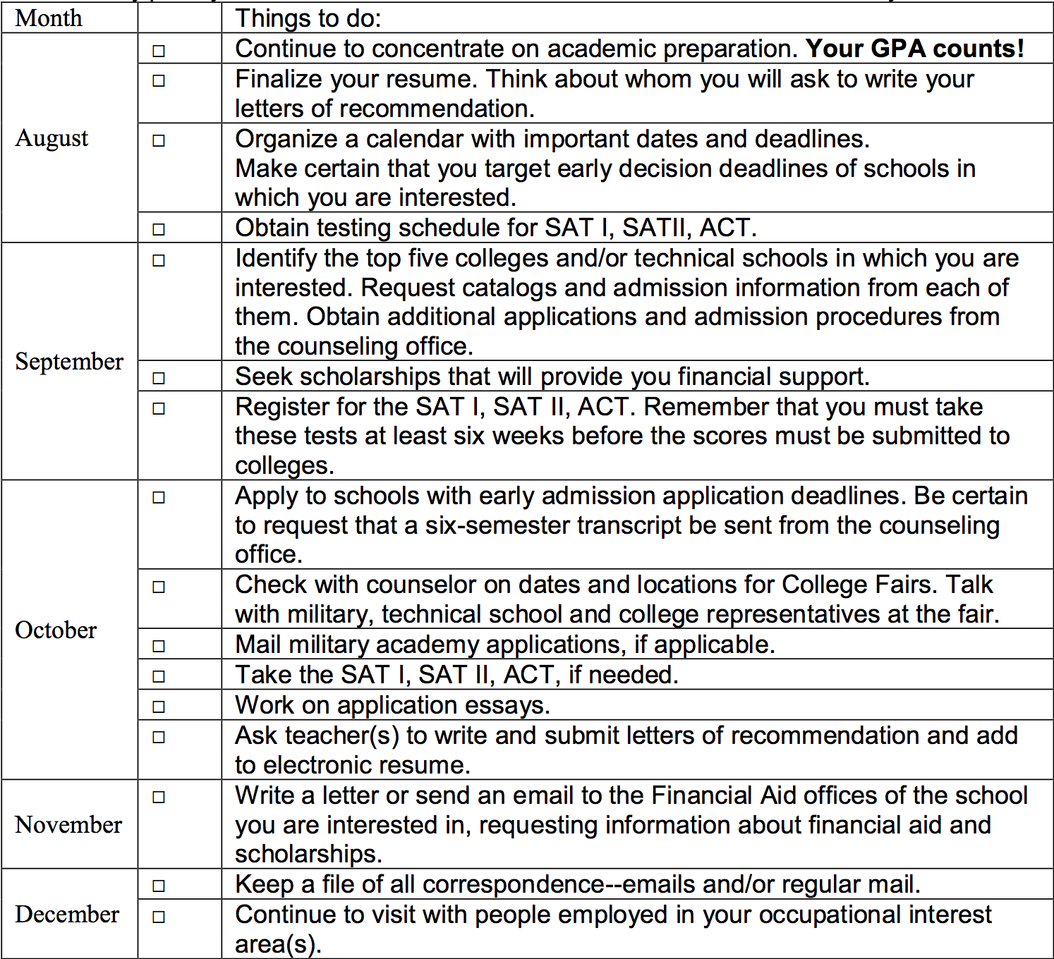

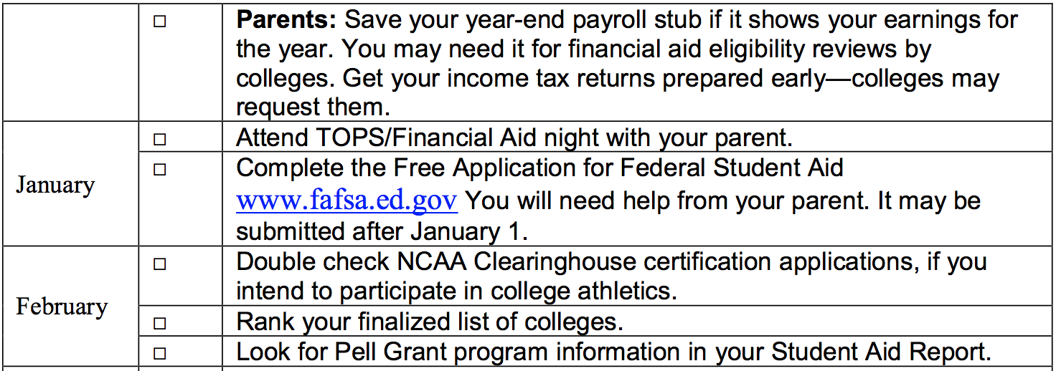

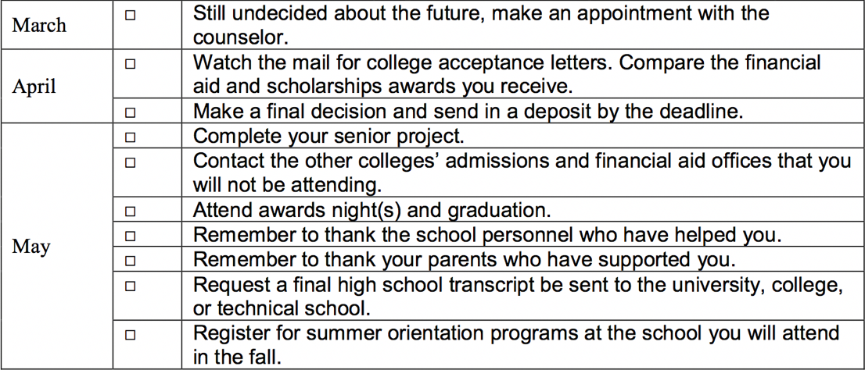

Resume Boosters

In addition to athletic participation and service learning, Glenbrook School offers a wide variety of clubs to supplement each students’ well-rounded education as well as their resume. A description of these clubs is located below so that each student may better describe the organization when necessary.

It should also be noted that specific terminology adds significant value to a resume. Notably, the words defined as 21st century skills-- creativity, critical thinking, communication, collaboration, adaptability, self-discipline, leadership and tenacity, should be strongly considered for use, if appropriate, when writing a resume.

Appendix II

Art: Art Club members will explore creativity by expressing oneself in art projects and crafts.

Astronomy: The Astronomy Club introduces students to the planets and stars of the cosmos by giving them an up-close encounter while using telescopes. The goal of the club is to create new methods to observe the night sky while promoting interest in astronomy.

Book Club: The Book Club meets in the library once a month. Students in grades 7- 12 are invited to join. The club will encourage students to read the assigned book for each six weeks and to share ideas and opinions about the book. The club will also have invited speakers who will broaden students’ knowledge of different authors and literary genre.

Bricks 4 Kids: A hands-on club where students in grades 4-6 build machines, buildings, vehicles, and other structures out of LEGO bricks, using one-of-a-kind model plans designed by Bricks 4 Kids.

Chess Club: The Chess Club will meet once a month to enjoy time to play the game.

Christian Club: The Christian Club is an organization devoted to maintaining high moral standards at school and at athletic events. Devotions are arranged weekly and many lecturers are welcomed during the year. The club meets on Tuesday and Thursday during lunch in the biology lab.

Close-Up: This program is a one-week Washington, D.C. Government Study Program is open to students in grades 11-12 who are interested in American history and government.

Coding/Games: Kids love creating and customizing their code through our interactive interface. And when they're done, they with web pages and projects that they

have built themselves.

Creative Writing: The club creates a safe place for students to write and share ideas which results in the publishing of student work in either a hard format or electronic format.

Dance: Dance club is an organization that allows its members to experience the wonder and joy of dance.

Drama: Drama club exists for the purpose of providing our students the opportunity to explore all aspects of theatre. Our students learn the skills of stagecraft, including all areas of acting and stage production. We also take part in workshops to learn acting and improvisation skills, as well as going together to see performances and shows throughout the area.

Entrepreneurship: Students will learn about starting businesses, fostering creative ideas, establishing strong relationships, and embracing opportunities.

Environmental Club: The goal of this club is to raise awareness of ecological concerns through education.

Explorers: Explorers is a youth development program for student who are in the 8th grade. Its purpose is to provide positive experiences to help young people mature and to prepare them to become responsible and caring adults.

4-H Club: Every month 4-H agents meet in the school for the regular 4-H meeting. Some popular projects include computers, public speaking, animal science, personal development, foods and nutrition, home environment, automotive, and many others. Local, district, and state competition is made available for 4-H members. Thousands of dollars in local scholarships are available to outstanding 4-H members as well as numerous awards, trips, and camps. The 4-H program is a part of the LSU Agricultural Center.

Fishing Club: For people who want to learn more about fishing.

FBLA: The FBLA is a national organization, focusing on preparing students for business, office, or business education careers. Members must be presently or previously enrolled in a business course. Members compete with their colleagues on local, district, state, regional, and national levels. Dues are required.
Junior Civitans: Junior Civitan is a community service organization for students. Junior Civitan members seek to meet the needs of our world and promote progress in a world of change

Junior Varsity Cheerleaders: The same rules that apply to varsity cheerleaders apply to junior varsity cheerleaders. Junior Varsity Cheerleaders will be chosen from girls in grades 7-9.

Kids in the Kitchen: Get ready, get messy, and make some fun, making healthy snacks and meals.

Louisiana History Trip: The LA History Trip is an annual extended field trip for all 8th graders.

Math Counts: Math Counts is a national enrichment, coaching and competitive program that promotes middle school mathematics achievement. Students in the sixth, seventh, and eighth grades who are selected by their math teacher and who show interest in being a member are invited to join.

Music Club: Activities similar to Circle of Drums

National Honor Society: NHS students work to help the community and build character and leadership skills. To be eligible for membership in NHS, students must have a 3.5 GPA or higher

after the fourth six weeks of their 10th grade year, have successfully completed at least one honors course or dual enrollment, be enrolled in at least one honors or dual enrollment course, provide evidence of service to the community, and possess exemplary qualities of character and leadership.

PALS: Students meet with a kindergartener and share a special book and/or activity.

Photography: The Photography Club is invitation only to students with an interest in learning techniques for taking good pictures for the yearbook and to have their pictures submitted for at least one art contests.

Prom Committee: This annual event is sponsored by the Junior Class. At the event, junior students are presented their class rings, and seniors are honored with a video presentation which highlights their participation at Glenbrook.

Quiz Bowl: Quiz Bowl meets and prepares for tournament matches that include questions takes from a variety of subject matters, including history, art, literature, languages, mathematics, and science. The club is limited to 10 members, invitation only with a required teacher recommendation.

Robotics: 4-H has developed a comprehensive robotics program to inspire young people and develop an early interest in robotics engineering and technology.

Scrabble Club: Students meet and play Scrabble. Traveling to tournaments is at the discretion of the sponsor.

Sign Language Club: American Sign Language Club is an opportunity for students to learn the basics of signing as well as get a look into the world of Deaf culture.

SMILE Club: Students Making Individual Lives Easier at Glenbrook (SMILE) members

provide encouragement for students.

Spanish Club: The Spanish Club has as its purpose to increase awareness and knowledge about Spanish speaking countries and to practice conversation Spanish.

Sports Medicine: This is a club for those students who are interested in working with the athletic sports representative from a local orthopedic clinic. The club members must attend at least two sporting events each month. Community service hours will be awarded for the after-school hours.

Student Council: The governing body of Glenbrook consists of president, vice-president, secretary, treasurer, parliamentarian, and representatives from grades 7-12. Each is elected from the student body. Requirements are put forth by the Head of School yearly. Activities for the year are Alumni Homecoming Reception, blood drive, and Teacher Appreciation Week.

Ventures: The Ventures Club which is for boys and girls gives students the opportunities to build character, develop citizenship, and foster personal fitness.

Appendix III

Service Learning Guidelines

The purpose of the Service Learning Graduation Requirement is to acquaint high school students with the need to become participating agents of change by providing service to both their school and community.

Service Learning is defined as:

An educational method by which participants learn and develop through active participation in service that is conducted in and meets the needs of a community. Service learning is coordinated with a school or community service program and with the community. It is integrated into and influences the lifelong learning of a participant and includes structured time for the participants to reflect on the service experience.

Service learning teaches the skills of civil participation and develops an ethic of service and civic responsibility. Students can provide service in the community on a voluntary basis to public, nonprofit agencies, civic, charitable and governmental organizations and school campus.

The Service Learning Graduation Requirement

Community involvement is critical to success in education. Student participation in community service activities build an awareness of society and a connection between classroom and real-world issues. Service Learning is a method through which students learn about and develop a commitment to addressing needs in their communities. Service Learning hours provide students with the opportunity to develop a long lasting sense of responsibility to society.

Students must meet the annual requirement of 20 service learning hours performed off campus plus a written reflection. Students are encouraged to use their service learning experiences as discussion or written topics whenever appropriate as a part of class assignments. No student is exempt from the Service Learning requirement.

General Guidelines

1. All services must comply with the policies of Glenbrook School.

2. Student volunteer service hours may be earned as a service to the community.

3. Services for which a student or an organization that a student belongs to receives financial/or other substantial compensation will not be counted. This would include revenues from ticket sales or donations. For example, participation in a car wash sponsored by a club would not count as community service. An exception to this guideline would be if the organization is donating the profits (less expenses) to a charity. Another example, the school chorus puts on a performance at which admission is charged and all of the proceeds less the cost of cleaning their uniforms are donated to a charitable organization.

4. Participation in and travel to theatrical musical performances, festivals or community events will count as service hours if both (a) and (b) below are met:
- The performance meets an identified community service need.
- The performance is not a fundraiser for the organization nor the student is paid or receives academic credit. For example, students participating in the school chorus may receive hours for performing at a retirement home, charitable and civic events or for a non-profit agency.

5. A student may earn volunteer hours by helping at an event or performance at which admission is charged or a donation collected, providing that the student is not a member of the organization benefiting from the event.

6. Rehearsal and practice time will count for volunteer service projects to be performed or conducted specifically to meet a community service need.

7. Activities organized by profit making or non-profit organizations to address a community service need will count as volunteer service hours.

8. Services performed for day care centers, retirement homes, and animal hospitals count for volunteer hours. A student may earn service hours by volunteering with a doctor, lawyer, or dentist only when “pro bono” work is being performed. For example, if a doctor volunteers to give physical examinations to school athletes, a student may assist and earn service hours.

9. Service performed on staff at non-profit athletic or music camps for no financial compensation will count as volunteer services hours.

10. Time out of class may not be used for hours; however, a maximum of four (4) volunteer hours per week can be earned by participation in an organized, supervised and approved peer tutoring program in which the tutoring takes place when school is not in session. However, the tutoring sessions cannot take place during any of the tutor’s academic classes.

11. Service hours will be awarded for students volunteering on political and issue campaigns. To receive service hours, a student cannot be paid for working on the political campaign. A student is not eligible to receive service learning hours for volunteering on the political campaign of a school board employee or in school board elections. Students are not eligible to receive service learning hours for campaigning or being engaged in political activities during the school day and on school campuses.

12. Students may receive volunteer hours for helping at religious institutions.

13. In general, service rendered directly to a for profit institution or organization will not count. Volunteering at a “For Profit” summer camp does not qualify for service learning.

14. Service for a student’s family or family business will not count.

15. Service performed as the result of disciplinary action taken by the school or the courts will not count.

16. Participation in campus or competitive activities such as athletics, plays, debate meets, etc. will not count.

17. Service performed as an academic requirement, other than that performed as part of the approved volunteer service learning courses will not count.

18. Babysitting, or similar services, performed for an individual family, will not count. Babysitting services for school related activities will count.

19. Volunteer hours may not be certified by a family member or fellow student

20. Service hours will not be awarded for any in kind or monetary donations of any kind including canned food collections, toy collections, etc. For example, a service hour value cannot be established for the donation of a specific number of cans of food. The time spent collecting the cans of food (as long as it does not occur during the school day) can count.

21. Participation in self-improvement workshops, clinics, conferences or conventions will not count for volunteer hours. If workshops, clinics, etc. have a specific service component, the hours spent on that activity can count.

22. Hours spent helping others (not family members) in disaster preparations or clean up may count.

23. A letter on the organization’s letterhead (Service Hours must be earned off campus.) must be obtained by the student to document the volunteer hours spent. The student must collect the letters and submit them to their social studies teacher listed in the table below on the day of that class’s final test. The Service Learning hours will be 25% of the final exam grade. Service Learning documentation and reflections must be submitted to their social studies teacher on the date of the final exam. If a student does not submit evidence of completing 20 hours of service learning, the student will automatically receive a grade that reflects a 25% decrease in the total points awarded. This includes students who are exempt from the final examination. No one is exempt from service hours. Seniors must submit evidence of completed service hours prior to Senior Project. A score of 500 points will be added or subtracted from their sixth six weeks grade.

Grade Teacher

7 7th Grade history

8 LA History

9 Civics

10 World Geography/History

11 American History

12 Law Studies, Sociology, or Western Civilization

If a student’s volunteer hours have been denied by the school, the student may appeal that decision to the Head of School or designee. The appeal must be in writing, and copies of the letters referencing the hours in question must be attached.

Appendix IV

Senior Portfolio
A requirement for graduation is that the following form with all signatures must be submitted to Dr. Coyle on graduation practice day.

Student Name _______________________________________

Category | Number  Required | Item Submitted | Date Due | Teacher’s Initials
Job Shadowing Experience | 10 total hours | Parent Approval Form | Beginning of 6th Six Weeks | Dr. Coyle  _____
 |  | Community Mentor Acceptance Form | 4Weeks Prior to Shadowing Experience | Dr. Coyle  _____
 |  | Community Mentor Final Observation Form | Graduation Practice Day | Dr. Coyle  _____
 |  | 500-word paper | Graduation Practice Day | Dr. Coyle  _____
Service Learning | 20 hours | Essay | Last Day of Senior Class Instruction | History Teacher  _____
 |  | Letters Documenting Service | Last Day for Senior Class Instruction | History Teacher  _____
Research Paper | 1 | Graded Paper (Passing) | Due Date Assigned by English Teacher | English Teacher  _____
 |  | Graded Rubric | Due Date Assigned by Teacher | English Teacher _____
 |  | Self-Evaluation Paper | Last Day of Senior Class Instruction | Dr. Coyle  _____

Job Shadowing Information

Student Requirements:

Submit Parent Approval Form at the beginning of the 6th six-week grading period.

Submit the Community Mentor Acceptance Form 4 weeks prior to shadowing experience

Complete a minimum of 10 hours of job shadowing.

Write a minimum 500-word paper for job shadowing experience.

Explain the following for job: Job description. (Explain responsibilities and/or duties.) Education requirements License or certification requirements Expected salary range

After reflecting on your job shadowing experience, would you consider working in this field; why or why not?

Due Date Information:

Complete your job shadowing experience and documentation by the graduation practice date.

Submit Community Mentor Final Observation Form and paper to graduation coordinator.

Research Paper Self Evaluation

Answer the following questions as accurately as you can:

1. List 3 interesting ideas or facts you learned about your research topic.

2. If you were to write your paper over, what would you change and why?

3. Who or what helped you the most when you were writing your paper? How?

4. What was the biggest problem related to researching or writing your paper that you had to solve? What was the solution?

Rate your paper 1-2 = low, 3-4 = high

_____Demonstrates correct format throughout

_____Begins with thoughtful, interesting title

_____Centers around an engaging thesis

_____Starts with a powerful, clear introduction

_____Aligns the body of paper clearly to thesis

_____Provides a paper interesting to read

_____Demonstrates conclusion with a strong thesis 'wrap'

_____Represents accurate, thorough citing throughout paper

_____Illustrates complete/accurate works cited page

_____Contains a thorough works consulted page

_____Indicates skilled demonstration of mechanics, grammar, punctuation

_____Demonstrates strong understanding of voice, word choice, organization, content

_____Engages use of quotes from interview

_____Shows excellent balance between research and personal voice

_____Illustrates strong application of sentence variety

_____Exemplifies careful and skillful editing

_____Represents a personal learning stretch & high level of personal satisfaction

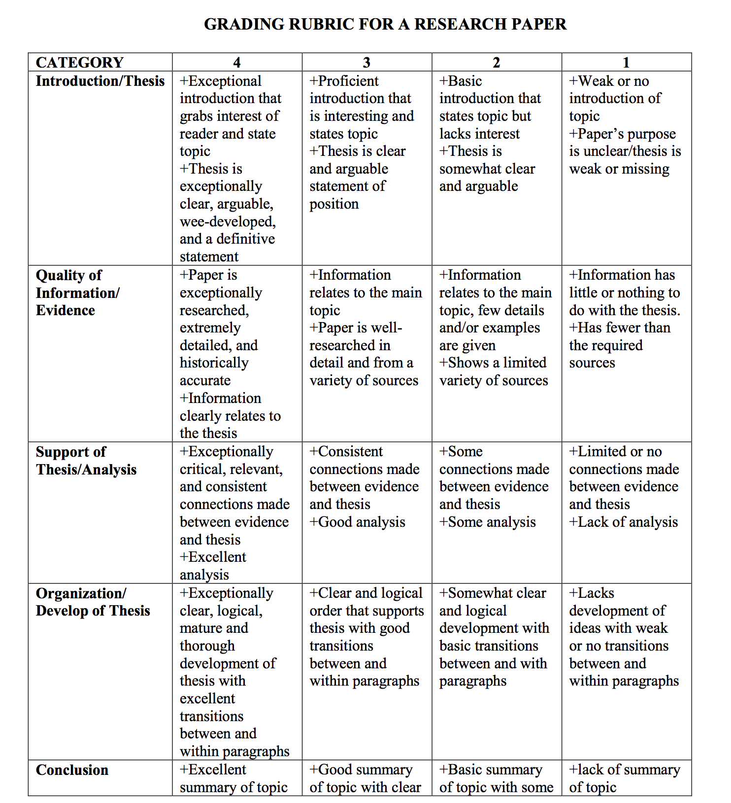

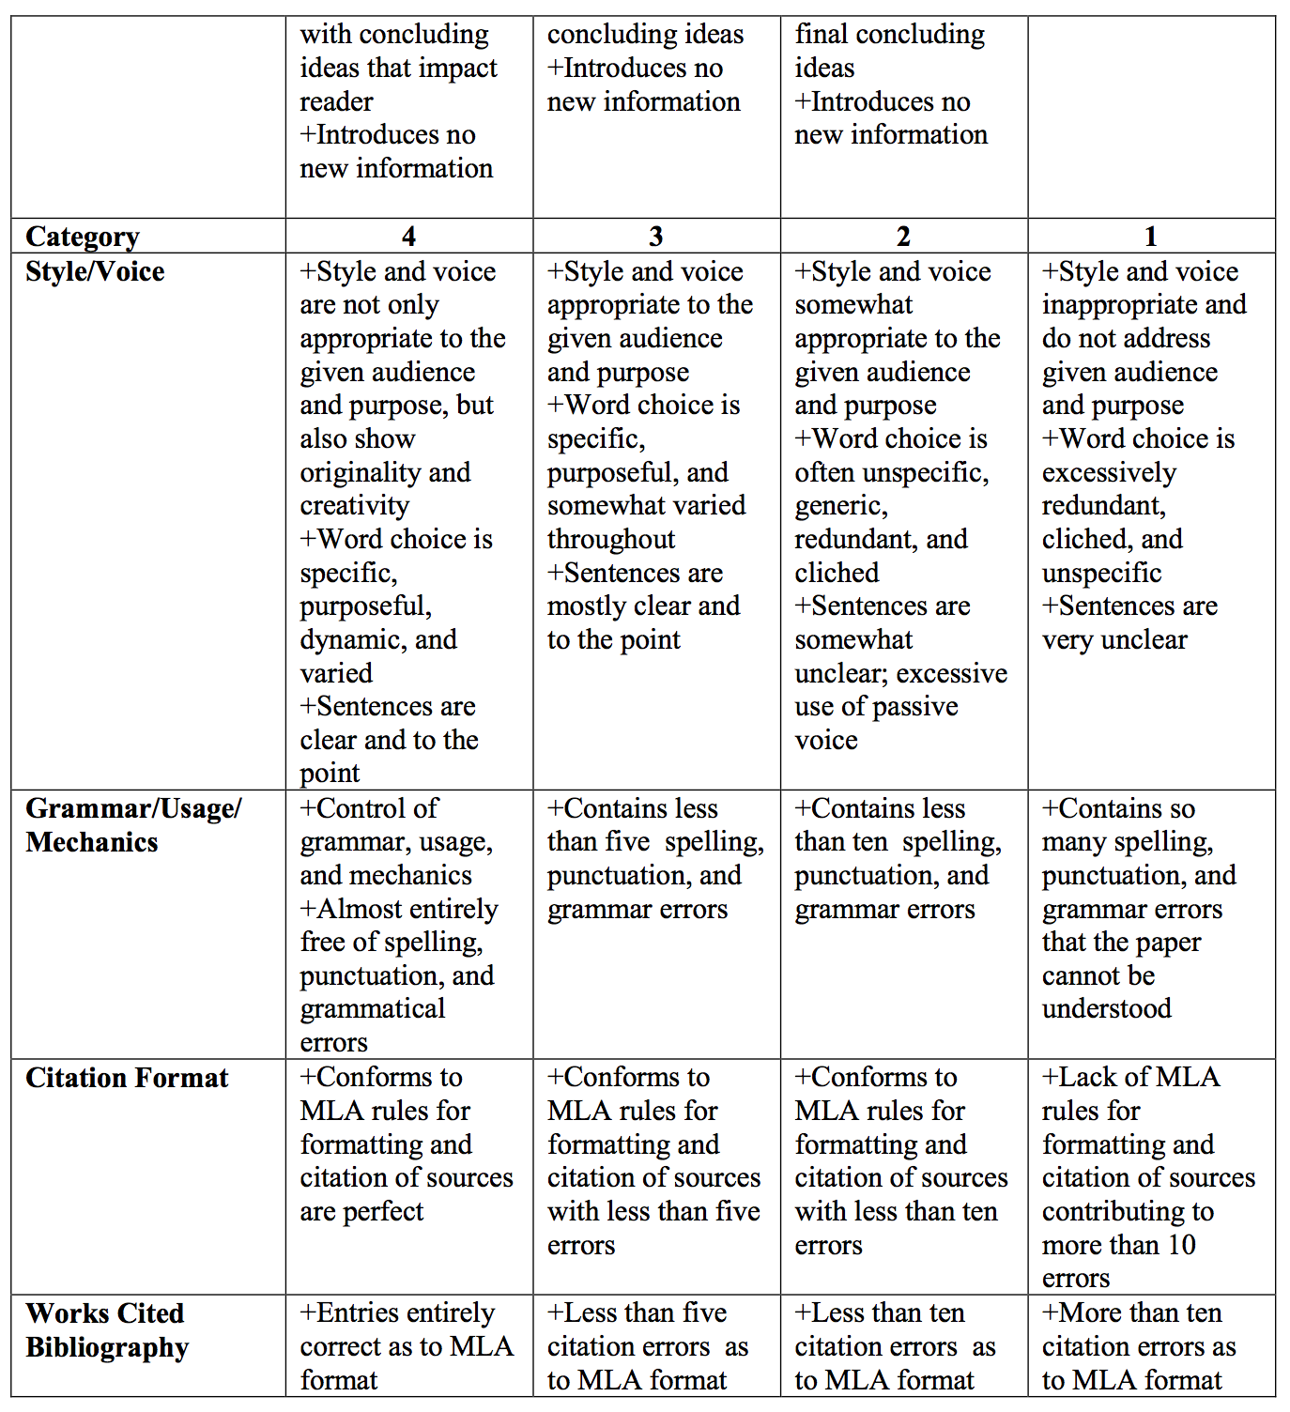

Parent Approval of Community Mentor

Student Name ________________________________________

Student’s Senior Project Area of Interest ___________________

A Community Mentor is an important and mandatory resource your child will utilize in order to successfully complete his/her senior project. Students are not to work for a family-owned business, are not to receive remuneration for services rendered, and cannot use a part-time job as a senior project. To successfully complete the project, the student and mentor must spend at least 10 hours communicating with one another.

Please list the name and contact information of the individual whom your child would like to serve as his/her Community Mentor.

Community Mentor’s Name _____________________________

Field of Experience __________________________________

Contact Information:

Business Phone Number: __________________________

Other: _______________________________________

To ensure the safety of your child and others, we urge you to meet your son/daughter’s mentor and to verify that the Community Mentor has the necessary training and expertise for the area of interest your student has chosen.

Please have a conversation with your children concerning the proper methods of communication and the actions that should be taken if they find themselves in inappropriate or uncomfortable situations.

It is recommended that you regularly visit the location where your child and the Community Mentor are working and keep phone number(s) needed to contact the Community Mentor. There will be no supervision provided by the school while s/he is working with the Community Mentor.

Although the school may periodically check with the Community Mentor to determine if the student is completing the project in a timely fashion, it is the responsibility of the parents/ guardians to ensure that the Community Mentor is (1) providing their son or daughter with a safe environment and (2) following all necessary safety procedures.

The Community Mentor and/or the parent(s)/guardian(s) are helpful in guiding the student through the project phase of the Senior Project; however, the student alone is ultimately responsible for completing the project components and submitting all of the required forms and assignments on the proposed time table. Senior Internship represents the student’s learning rather than the work of the Community Mentor or the parents.

PLEASE CHECK THE FOLLOWING BOX:

I understand that the above mentioned Community Mentor will be interacting with my child without the supervision of other adults, and I am comfortable leaving my child with this person.

**The school corporation and its officers or representatives shall be excluded from liability and/or medical expenses that may develop or result from your student working with a mentor on their senior project. This includes but is not limited to activities or meetings with the mentor, including travel to and from the activity. The school corporation has no control over the daily activities of the senior project, the quality of the activity or qualifications of the mentor. Glenbrook School does not perform criminal background checks on mentor.

Parent’s Signature ___________________________ Date _________________________

Community Mentor Acceptance Form

Student’s Name: _________________________________

Mentor’s Name: _________________________________

Field of Expertise: ________________________________

Business Phone: _________________________ Cell Phone: ___________________________

Address:

Email: _______________________________________________________________________

Thank you for volunteering to serve as a community mentor for one of Glenbrook’s senior students. This is a very important role, and your efforts are greatly appreciated.

The suggested responsibilities of the mentor are: provide and guide the student through the project process, confirm the number of hours the student has spent working with the mentor, and verify that the project has been completed. Please plan to spend several hours with your mentee. Your role as a mentor is one of guidance and support. The student is responsible for making and keeping all arranged appointments, performing all necessary research, planning and implementing the project and providing any necessary supplies.

In addition to guiding the mentee, the community mentor will need to complete an evaluation at the conclusion of the mentee’s work on the project.

If you have any questions, please contact the Senior Project Coordinator at 377-2135

Community Mentor Signature Date

Please attach your business card.

Community Mentor Final Observation Form

Student’s Name: _________________________________

Mentor’s Name: _________________________________

Dates of Student Shadowing Experience: _________________________________

Student Arrived at _______________ am/pm and Left at ________________ am/pm.

As the community mentor, you have worked closely with and have guided this student through phases of his or her senior project. We would appreciate your honest feedback on the student’s experience. This observation will become part of the student’s final portfolio. Thank you for the time and effort you have spent helping our students transfer high school experiences to community applications.

Student Performance Feedback
 | Excellent | Acceptable | Lacking

Appearance

Attendance

Attitude

Efficiency

Effort

Follow-Through

Punctuality

Initiative

Please include additional comments concerning this student’s performance on project activities and your experiences as a mentor.

Please place this form in the attached envelope and give it to the student at the conclusion of his/her shadowing experience.

Thank you for being an important partner in this student’s education!

.

Appendix V

Rules for ISS

- Be on time. Anyone who arrives after the door is closed is tardy and will receive an additional break or lunch detention.
- Be in compliance with the dress code BEFORE you enter the room.
- Enter the room quietly and sit down, one person per table. Sit facing forward with your feet on the floor.
- Do not talk. There will be no disruption of any kind (making noises, making faces, trying to get someone’s attention, laughing, etc.). The monitor will determine what is meant by “disruption.” If you are disruptive in any way, you will be removed from the classroom and given an office referral.
- Students must bring and work on reading or school work.
- You may not sleep. You may not put your head down on the desk.
- No one will be allowed to leave the room (with the exception of getting lunch). You must use the restroom before or after detention.
- Food:
- Bring your food to detention during break. Remember your priority is to make it to the detention room ON TIME. Water and occasionally snacks, along with plastic plates and utensils will be available for sale by the Junior Class in the detention room. “I wasn’t able to get my food on time” will not be an excuse for being late.
- You many not wait in the lobby for food to be delivered. Please notify the person bringing your lunch to notify Mrs. Davis when they arrive with your food, and she will call on the intercom.
- Food is eaten in silence.
- All trash must be thrown away, and the area where you are eating must be clean when you leave.
Consequences for Skipping ISS
- During first period class, the list of students' names who have been assigned ISS will be read aloud; however, it is YOUR responsibility to check the posted lists. The ISS List for the day will be posted outside Room #2, on the door at the end of the hall leading to the gym, and on the bulletin board outside the H.S. student restrooms. . In addition, the list of names will also be posted outside room #2 daily. It is the STUDENT'S responsibility to check the list to determine if his/her name is listed.
- If you skip ISS (lunch, break, or both), you will be required to make up the one you missed, as well as an additional ISS assignment.
- Students who habitually skip ISS will be referred to the Assistant Head of School and the Athletic Director for appropriate disciplinary action.
- Continued failure to comply with the rules of ISS will be reported to the administrative staff for more serious disciplinary action.
- Your ISS report will be attached your report card each six weeks.

.

Appendix VI

Social Media

Staff, Parents, and Students of Glenbrook School
support good practice on Social Networking Sites

The Head of School and staff of Glenbrook School have agreed on an approach to the use of Social Networking sites. We are now inviting parents to join us in setting a good example for our children.

All parents are invited to join staff in setting a good example for our children by:
- Demonstrating courtesy and respect for students, parents and staff when comments are placed on social networking sites.
- Ensure appropriate language is used in any comments placed on social network sites.
- Addressing any issues or concerns regarding school, directly with the Head of School or member of staff rather than posting them on social media.
- Not using social network sites to make derogatory comments or posting photographs which could disrespect students, parents, staff members, the leadership teams, and trustees.

We agree:
- We will meet with you and use the Governing Bodies policies and procedures to resolve concerns.
- We will work hard to resolve any concerns in the best interest of the whole community.
- We will act in the best interest of the whole community and honor our duty of care to our students.
- We will not use public social networking sites to conduct school business or communicate with any pupil in the school. (Private groups are allowed – for example; a Facebook group dedicated to the class of 2018.)
- We will not use social networking sites within lesson times (for personal use).

Cyberbullying: Glenbrook School is committed to ensuring that all of its staff, parents/guardians and students are treated with dignity and respect. Bullying and harassment of any kind will not be tolerated. Cyber-bullying methods could include text messages, emails, phone calls, instant messenger services, circulating photos or video clips or by posting comments on web sites, blogs or in chat rooms.

Appendix VII

Internet Use Permission Form

Internet access is available to teachers and students at Glenbrook School for educational research and communication. The Internet is an electronic highway connecting thousands of computers all over the world and millions of individual subscribers. With is access come the availability of materials that may not be considers to be of educational value in the context of the school setting. However, the valuable information and interaction available on this worldwide network far outweighs the possibility that a user may access materials that are not consistent with educational goals of his/her project. Every precaution will be taken to restrict access to controversial material.

The school’s staff will provide appropriate supervision and instruction regarding use of the Internet. We will make all reasonable efforts to see that our students do not access inappropriate material, and it is unlikely that a student will accidentally access an unacceptable web site or become involved in inappropriate communications. However, it is impossible for us to guarantee that a student will not do so. Each student has a responsibility to make wise choices and follow school policy.

INTERNET USE POLICY: The use of the Internet by a student is a privilege, not a right, and inappropriate use will result in a cancellation of the student’s privilege. The librarian, teacher, and/or Head of School will deem what is inappropriate use; their decision is final.

Please go over the Internet Use Policy with your child and make certain that he/she understands his/her responsibility to follow the policy. We appreciate your cooperation in insuring that the wonder educational opportunities which our students will receive through appropriate use of the Internet will not be jeopardized because of imprudent behavior.

As a parent/guardian, I have read the policy regarding the use of the Internet and agree that my child(ren) may participate and shall abide by this rule. Finally, I will not hold Glenbrook School or any teacher liable for any damages incurred or information accessed through the use of the computer system.

