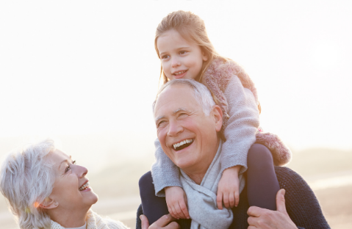

Glenbrook Grandparents’ or Grand Friends’ (GGs) Day
Come to Glenbrook and eat lunch with your grandchild or grand friend. We will be having GG Days throughout the school year. If you cannot come next week, there will be other days. Please come on your assigned day. First, you need to complete the RSVP below so we can have enough food. On the day of your visit, please go to the library first, and then you will be escorted to your grandchild’s/grand friend’s classroom. We look forward to seeing you.
Monday, August 22- Kindergarten GGs
Tuesday, August 23-1st Grade GGs
Wednesday, August 24-2nd Grade GGs
Thursday, August 25- 3rd Grade GGs
Friday, August 26-4th -6th Grades GGs

By Thursday, August 18, please complete and have your grandchild or grand friend return to his/her homeroom teacher.

I, _____________________, plan to eat with my grandchild/grand friend on the date(s) circled above.

